Low Washer Fluid RTT – CGEA1.3- Modified for UP375 Specific

Functional Description

The purpose of the Low Washer Fluid indication is to inform the driver that the Washer Fluid is low.

The Low Washer Fluid Indicator correlates the Washer Fluid Switch Status (HW) signal and the Operational_Mode to illuminate or extinguish the Low_Washer_Fluid_RTT.

The Low_Washer_Fluid_RTT shall provide an iconic representation that will illuminate or extinguish to inform the driver of Low Washer Fluid issues.

This section describes the RTT function and sets a flag that is used by the Message Center display (See Message Center Section for details of Message Display Algorithm).

The UP375 clusters have to interface to both legacy C1MCA and CGEA 1.3 washer bottles.
C1MCA – Cluster logic is “open circuit when empty” & “closed circuit when full”
CGEA 1.3 – Cluster logic is “closed when empty” & “open circuit when full” (idea is to save unwanted power consumption)

Thus, a configuration is added to accommodate both types of washer bottles.

Interfaces

Interface Context Diagram (I/O Block Diagram)
Figure 1. Low Washer Fluid Indication Function
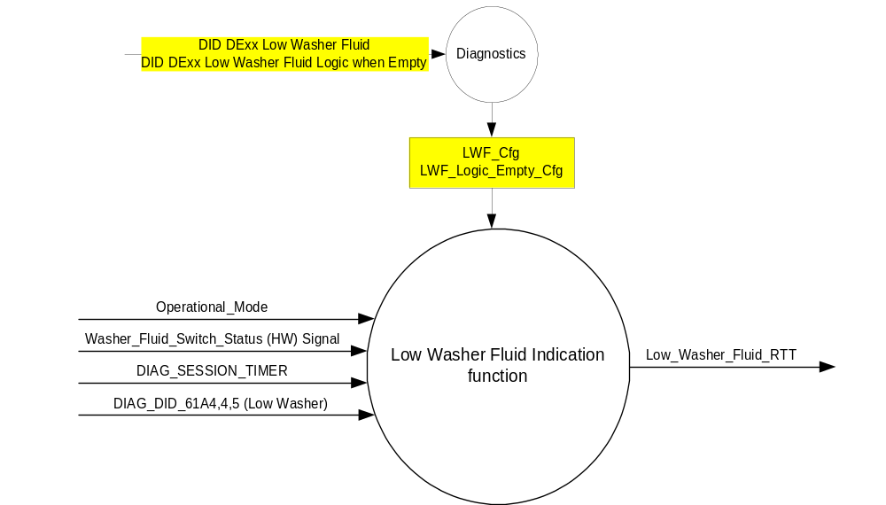

Inputs
      - INTERNAL:
            - DIAG_SESSION_TIMER
            - Operational_Mode
            - DIAG_DID_61A4,4,5 (Low Washer)

Washer_Fluid_Switch_Status (HW) Signal.
- To be sensed by a micro A/D input port or Digital port
- Sensing circuit to sink a minimum current of 7 mAmps at 13.25 Volts thru the Washer fluid switch.
- To have 0 to 50 ohm input under all operating voltage conditions to be closed.
- Digital switch inputs shall be debounced with a minimum of 5 consecutive samples over period between 40ms and 50ms. All samples must be identical in order to assert a new debounced value. Typical maximum output delay = 73 msec: 50 msec to debounce input, 20 msec to process it and 3 msec to turn on the output.

When LWF_Logic_Empty_Cfg = 0x0 (Ground)
- Low Washer Fluid switch will be closed to ground when fluid is low resulting in the illumination of the low washer indicator.
Washer Fluid Condition | Washer Fluid Switch Logic | Washer Fluid Switch Input | Washer_Fluid_Switch_Status
OK | Open | >50 ohms | 0X1(Ok)
Low | Closed | =< 50 ohms | 0X0(Low)

When LWF_Logic_Empty_Cfg = 0x1 (Open)
- Low Washer Fluid switch will be open circuit when fluid is low resulting in the illumination of the low washer indicator.
Washer Fluid Condition | Washer Fluid Switch Logic | Washer Fluid Switch Input | Washer_Fluid_Switch_Status
OK | Closed | =< 50 ohms | 0X1(Ok)
Low | Open | >50 ohms | 0X0(Low)

Outputs
Low_Washer_Fluid_RTT, which is used to control the state of the Reconfigurable Telltale

Function/Performance

Operational Modes

Mode | Differentiating Vehicle Conditions
Sleep Mode | Low Washer Fluid RTT OFF
Limited Mode | Low Washer Fluid RTT OFF
Normal Mode | Low Washer Fluid RTT ON / OFF
Crank Mode | Low Washer Fluid RTT ON / OFF

The above table references the setting of the RTT flag as per this section. However, the actual RTT display operational modes are displayed in the Message Center section of this SPSS.

Voltage Levels

Refer to the Cluster Features table located in the Operational Modes and Voltage Range Strategies Section in this SPSS

Human-Machine Interface

Visual

Indicator Graphics / Display Format
Refer to Message center function Description reference Text Message List warning message ID W450.


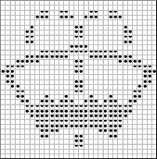

Pixel Definition C.05

For actual symbol definition see pixel definition section in the message center section. The pixel representation is based upon the symbol definition database # C.05 of the 03-0685 ARL requirement

Indicator Color Coordinates
Amber – Reference SDS IL-0017/IS-0379

Indicator Characteristics
Pixel Display in Message Center Display - Low Washer Fluid RTT

Audio
None

Switch Control Logic
Not applicable.

System Accuracy
The state of the Low_Washer_Fluid_RTT shall change within 100msec of a state change as indicated in the state matrix reference 1.3.5.1 Subsystem Algorithm Flowchart/ State Diagram

Operation: Performance and Functional

Subsystem Algorithm Flowchart / State Diagram
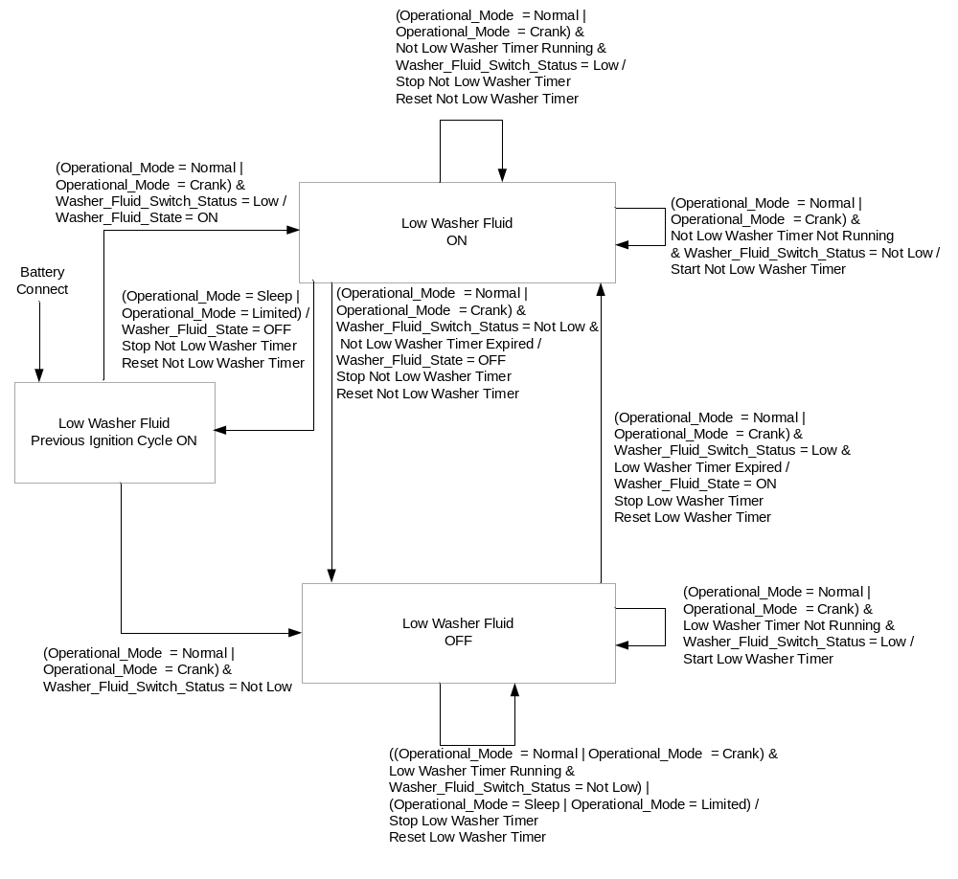
- State Matrix for Low Washer Fluid RTT Flag
Operational  _Mode | LWF_Cfg | DIAG_SESSION  _TIMER | DIAG_DID_61A4,4,5 (Low Washer) | Washer_ Fluid  _State | Low_Washer_  Fluid_RTT
Normal or  Crank | Enabled | Inactive | X | ON | Active
Normal | Enabled | Active | Not Received | ON | Active
Normal | Enabled | Active | ON (0x1) | X | Active
All Other Cases |  |  |  |  | Inactive
X = Don’t Care
Not Received = The state when a DIAG_SESSION_TIMER is active and the DID has not been received
* = Washer_Fluid_State as defined in state diagram

Operation Description (supports algorithm flowchart /state diagram)

- Low Washer Timer shall have a minimum resolution of 1 second and a maximum value of 60 seconds and a programmed initial value of 30 seconds.
- Not Low Washer Timer shall have a minimum resolution of 1 second and a maximum value of 60 seconds and a programmed initial value of 45 seconds.
- The actual RTT display operational modes are displayed in the Message Center Section of this SPSS.

Function Safety Classification (EMC)
Class B

Memory Storage
Parameter Name | Description | Value at  Battery Connect | Value at  Module Wake-up
Low_Washer_Fluid_RTT | Used to control the state of the RTT | Not Active (0x0) | Not Active (0x0)
Washer_Fluid_Switch_Status (HW) Signal | Hard wired signal used to control the washer fluid switch | Not Low (0x1) | No State Change
Washer_Fluid_State | Controls the state of the washer fluid as per State Diagram | OFF (0x0) | No State Change
DIAG_DID_61A4,4,5 (Low Washer) | Warning Lamp status 1, byte 4, bit 5 (Low Washer) | 0 (0x0) | 0 (0x0)
Operational_Mode | 4 state indicator for cluster operational mode | Limited | Limited, Normal or Crank

Parameter Name | Description | Value at  Battery Connect | Value at  Module Wake-up
DIAG_SESSION_TIMER | Timer used to time-out a diagnostic session | Inactive | Inactive
Bulb_Proveout_Timer | Internal command directing proveout | Inactive | Inactive
Self_Entry_Bulb_Check_Timer | Timer used in diagnostic session to do a self check of telltales | Inactive | Inactive
Low Washer Timer | Timer used to determine washer fluid level | Inactive | Inactive
Not Low Washer Timer | Timer used to determine washer fluid level | Inactive | Inactive

Parameter Name | Units | Offset | Resolution | Min/Max Value | Init Value
Low Washer Timer | Seconds | 0 | 1 | 0/255 | 30 (0x1E)
Not Low Washer Timer | Seconds | 0 | 1 | 0/255 | 45 (0x2D)

Prove Out
No

Reconfigurable Telltale
Yes

Message Center Msg
See Message Center Section for strategy of displaying RTT based upon state of the RTT flag

Error Handling

Missing Message Strategy
None

Diagnostics

Self Test
None

Engineering Test Mode
Reference section “Dealer / Engineering Test Mode (ETM)”

Part II Performance

Supported Diagnostic DIDs (Service $22 and $2F)
Number | DID / CommonID Name | DID Type
61A4 | Warning Lamp status 1, byte 4, bit 5 (Low Washer) | Bit Mapped

Supported Diagnostic Trouble Codes (DTCs)
DTC | Description | When Logged

DID DExx Configuration
Block  Num | Block Description | Byte(s) | Bits | State: Description | "0" | "1" | Default | Comments/Information
PACKETED BLOCKS
$00 | Option Content (B&A) | * | * | Low Washer Fluid | Disabled | Enabled | Disabled
 |  | * | * | Low Washer Fluid Logic when Empty | Ground | Open | Ground | All CGEA 1.3 washer bottles close to ground when empty. For them, set to 0x0 (Ground).  Legacy C1MCA washer bottles are open circuit when empty. For them, set to 0x1 (Open).
 | *Byte and bit location to be identified in Part II Specification for this cluster

Reference Specification

IS-0001 WARNINGS/INDICATORS/DISPLAYS PROVEOUT
IS-0046 INSTRUMENTATION MATERIAL RESISTANCE TO CLEANING
IS-0052 OPERATING VOLTAGES - FUNCTIONAL/PERFORMANCE
IS-0069 FUNCTIONAL IMPORTANCE CLASS
IS-0324 WINDSHIELD & OTHER REFLECTIONS
IS-0327 WARNING INDICATOR EVALUATION
IS-0329 FLICKERING OF LAMPS
IS-0379 NORTH AMERICAN WARNINGS AND INDICATORS STRATEGY

IL-0017 TELLTALE AND INTERIOR ILLUMINATION COLOR
IL-0021 CRAFTSMANSHIP - DISPLAYS
IL-0023 CLARITY/LEGIBILITY/READABILITY
IL-0025 INTERIOR ILLUMINATION INTENSITY
IL -0027 VISUAL CONTRAST
IL -0043 OPERATIONAL ENVIRONMENT FUNCTIONALITY
IL -0045 COLOR
IL -0047 TELLTALE; INDICATOR AND DISPLAY LIGHT INTENSITY
IL -0048 ILLUMINATION ACCEPTABILITY

03-0661 PLACEMENT: CONTROL AND DISPLAY LOCATIONS
03-0662 PLACEMENT: LOGICAL GROUPING FUNCTION AND USAGE
03-0664 PLACEMENT: DOWN VISION TO COMPONENTS WITH HIGH VISUAL DEMAND
03-0665 PLACEMENT: EXPECTED LOCATIONS OF CONTROLS AND DISPLAYS VDS
03-0670 INTERIOR VISIBILITY
03-0671 INTERIOR VISIBILITY: REFLECTIONS FROM COMPONENTS & SURFACES
03-0672 INTERIOR VISIBILITY: REFLECTIONS IN DISPLAYS
03-0673 INTERIOR VISIBILITY: VISUAL OBSCURATIONS
03-0674 INTERIOR VISIBILITY: ILLUMINATION CONTROLS / DISPLAYS
03-0675 INTERIOR VISIBILITY: VEILING GLARE
03-0677 INTERIOR VISIBILITY: SUNLIGHT WASHOUT
03-0681 IDENTIFICATION: CHARACTER AND SYMBOL SIZE
03-0682 IDENTIFICATION: LEGIBILITY
03-0685 IDENTIFICATION: SYMBOLS, ABBREV FOR CONTROL
03-0721 LOGIC OF OPERATION: OPERATIONAL STEREOTYPES
03-0722 LOGIC OF OPERATION: INTERPRETATION
03-0723 LOGIC OF OPERATION: USE OF SYSTEMS WITH VISUAL DISPLAYS

Revision History
SPSS Module Revision History

Revision Level | Name | Change Description | Date
1.0 | J. Gregoire | Initial release.  Updated for CGEA1.3. Based on CGEA Low Washer Fluid RTT STSS V1.0  No updates needed. | 5/11/2010
2.0 | J. Gregoire | Added Lower Washer Fluid Configuration  Figure 1 – Added Lower Washer Fluid Configuration  Table 1.0 – Added LWF_Cfg  Section 1.5.3 – Added DID DE00 Table for Lower Washer Fluid Configuration | 3/21/2011
2.1 | J. Gregoire | Section 1.3.3.2 – Added W450.  Section 1.3.5.1 State Flow Diagram – Correct path from Low Washer Fluid OFF back to itself. | 2/21/2012
UP375 Specific Version 1.0 | S. Watkins | Made UP375 specific to work with legacy washer bottles. Added configuration to handle Low = Open circuit or Low = Closed to Ground.  - Section 1.0 – Updated Title  - Section 1.1 – Updated description  - Section 1.2.1 – Updated Figure 1 Context Diagram  - Section 1.2.2 – Udated Input section with new table  - Section 1.5.3 – Added new config bit | 6/25/2014

